MUNICIPALITY OF CENTRE HASTINGS

NOTICE OF PUBLIC MEETING CONCERNING A PROPOSED ZONING BY-LAW AMENDMENT

TAKE NOTICE that the Municipality of Centre Hastings Council will hold a Public Meeting on March 1st, 2023, at 3:30 PM in the Council Chambers at 7 Furnace Street, Madoc to consider a proposed zoning by-law amendment under Section 34 of the Planning Act for the application numbered as ZBA01-2023.

Location of Subject Lands:
An application to amend the Zone classification for property located at 546 Quin Mo Lac, Madoc, ON. Part of Lot 15, Concession 11, Huntingdon, Municipality of Centre Hastings, Hastings County

A key map showing the location of the subject property is attached to this Notice.

The purpose and effect of the proposed zoning by-law amendment is:

Purpose:
To rezone a portion of the subject lands from the Rural (RU) Zone to the Rural Residential (RR) Zone. Areas zoned Environmental Protection (EP) Zone remain unchanged.

Effect:

The requested zoning by-law amendment will apply to the subject property to facilitate the following:

- To fulfill Condition 6 of Hastings County Consent File B114-22
Additional information and material relating to the application for the proposed zoning by-law amendments is available for inspection by any member of the public during regular business hours at the municipal office, 7 Furnace Street, Madoc.

If you wish to be notified of the decision of the Municipality of Centre Hastings on the proposed zoning by-law amendment, you must make a written request to Municipality of Centre Hastings at 7 Furnace Street, Madoc, ON K0K 2K0.

ANY PERSON may attend the Public Meeting and/or make written or verbal representation either in support of or in opposition to the proposed zoning by-law amendment.

If a person or public body would otherwise have an ability to appeal the decision of the Council of the Municipality of Centre Hastings to the Ontario Land Tribunal (OLT) but the person or public body does not make oral submissions at a public meeting or make written submissions to the Municipality of Centre Hastings before the by-law is passed, the person or public body is not entitled to appeal the decision.

If a person or public body does not make oral or written submissions at a public meeting or make written submissions to the Municipality of Centre Hastings before the by-law is passed, the person or public body may not be added as a party to the hearing of an appeal before the Ontario Land Tribunal (OLT) unless, in the opinion of the Tribunal, there are reasonable grounds to do so.

Dated at the Municipality of Centre Hastings 6th day of February 2023.

For more information about this matter, including information about appeal rights, contact:

Typhany Choinard, CAO/Clerk
Municipality of Centre Hastings
7 Furnace St., P.O. Box 900
Madoc, ON K0K 2K0
613-473-4030

Key Map

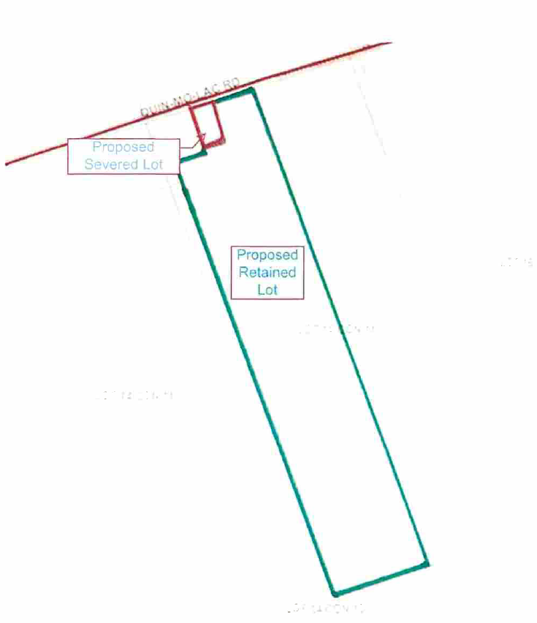

Subject Lands (Part of Lot 15, Concession 11, Huntingdon), Municipality of Centre Hastings

