COMMITTEE OF ADJUSTMENT
MUNICIPALITY OF CENTRE HASTINGS

PUBLIC NOTIFICATION

NOTICE IS HEREBY GIVEN THAT the following application MVA01-2023 under Section 45 of the Planning Act will be heard by the Committee of Adjustment in the Council Chambers in Madoc, Ontario (7 Furnace Street) on the 1st day of March 2023 at 3:30 p.m.

Application for a minor variance for the property located at:
208 St Lawrence Street West (Part of lot J, north of St. Lawrence Street west of Mill Pond, Concession 5, geographic township of Madoc Registered Plan No. 218, Village of Madoc) Municipality of Centre Hastings, County of Hastings was received.

The applicant has requested relief from sections:

SECTION 22 COMMUNITY FACILITY (CF) ZONE
22.4 REGULATIONS FOR NON-RESIDENTIAL USES

22.4.5 Minimum Interior Side Yard
22.4.5.b. Abutting any other [non-residential] zone 15 m (50 ft.)

Applicant requests a reduction to the minimum required interior side yard to 4 m (13.1 ft.)

SECTION 5 LOADING AND PARKING PROVISIONS
5.1 LOADING SPACE REGULATIONS

5.1.1 Loading Space
Area of Building Exceeding 2,300 m² but not 7,500 m² (80,731.97 sq. ft.): Loading Space [Required] 3

Applicant requests to reduce the minimum required loading spaces to 2
For more information about this matter, including information about appeal rights contact:
Typhany Choinard, Clerk
Municipality of Centre Hastings
7 Furnace St., P.O. Box 900
Madoc, ON K0K 2K0 613-473-4030

Signed written submissions in favour of or in opposition to the minor variance to By-law #2002-10, as amended, should be mailed to the Secretary prior to the hearing date. Alternatively, you may attend the hearing and make a submission to the Committee. If you wish to be notified of the decision of the Committee of Adjustment in respect to the application, you must submit a written request to the Committee. This will entitle you to be advised of a possible Ontario Land Tribunal (OLT) hearing on this application.

Further information on this application may be obtained by attending the office of the undersigned during regular business hours.

DATED this 10th day of February 2023.

Submitted by:

Typhany Choinard
Secretary, Committee of Adjustment
7 Furnace St., PO Box 900,
MADOC, ON K0K 2K0

File No. MVA01-2023 – Site Map Attached

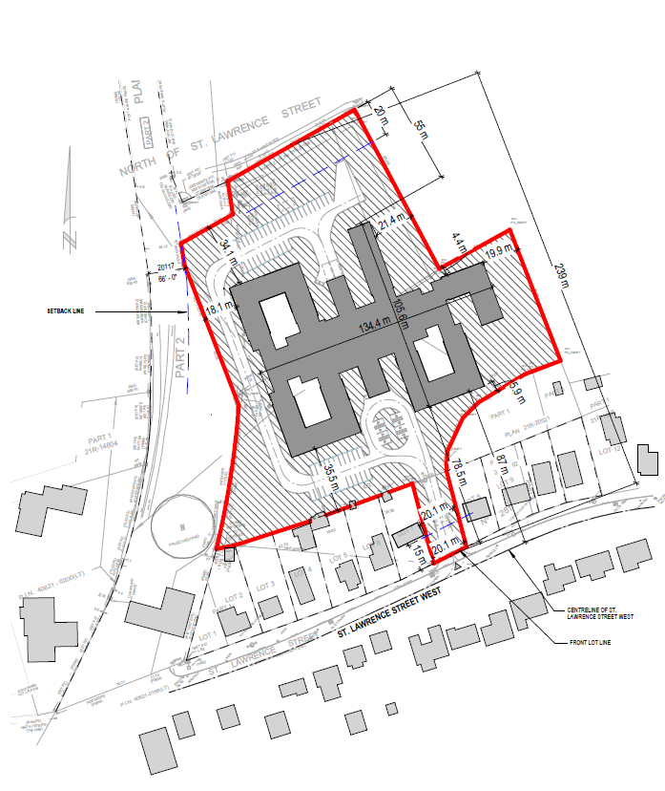
Subject Lands (Part of lot J, north of St. Lawrence Street west of Mill Pond, Concession 5, geographic township of Madoc Registered Plan No. 218, Village of Madoc, Municipality of Centre Hastings, County of Hastings.)

